TEST CASES

**Price calculation**

**R1 The customer gets 10% price reduction if the price of the goods reaches 200 euros.**

**R2 The delivery is free if the total weight of the goods is under five kilograms. Reaching 5 kg, the delivery price is the weight in euros. E.g. when the products together are 6 kilograms then the delivery price is 6 euros.**

**R3 The delivery remains free if the price of the goods exceeds 100 euros.**

**R4 If the customer prepays with a credit card, then s/he gets 3% price reduction from the reduced price of the goods.**

**R5 If the price reaches 200 euros and the customer pays with credit card, and the weight is under 5 kg, then the customer gets a 15% price reduction for the original price of the goods.**

**R6 The output is the price to be paid. Minimum price difference is EUR 0.1, minimum weight difference is 0.1 kg.**

**TESTCASE**:

1. To verify that the price of goods reaches 200 euros, that the customer get 10% of price reduction
2. To verify that the price of goods less than 100, weight of goods is less than 5kg, the delivery charge is free
3. To verify that the price of goods less than 100, weight of goods is greater than 5kg, the delivery charge is weight in euros
4. To verify that the price of goods greater than 100, weight of goods is less than 5kg, the delivery charge is free
5. To verify that the price of goods greater than 100, weight of goods is greater than 5kg, the delivery charge is free
6. To verify that the price of goods is less than 200 euros and paid with credit card, that the customer get 3% of price reduction
7. To verify that the price of goods is greater than 200 euros, weights of goods less than 5kg and paid with credit card, that the customer get 15% of price reduction
8. To verify that the price of goods is less than 200 euros, weights of goods greater than 5kg and paid with credit card, that the customer get 15% of price reduction and also added delivery charge is the weight in euros
9. To verify that the price of goods less than 100, weight of goods less than 5kg and paid with credit card, that the customer get 3% price reduction
10. To verify that the weight of goods less than 100, weight of goods greater than 5kg and paid with credit card, that the customer get 3% price reduction and also added delivery charge is the weight in euros
11. To verify that the price of goods greater than 100, weight of goods less than 5kg and paid with credit card, that the customer get 3% price reduction and also delivery charge is free
12. To verify that the price of goods greater than 100, weight of goods greater than 5kg and paid with credit card, that the customer get 3% price reduction and also delivery charge is free

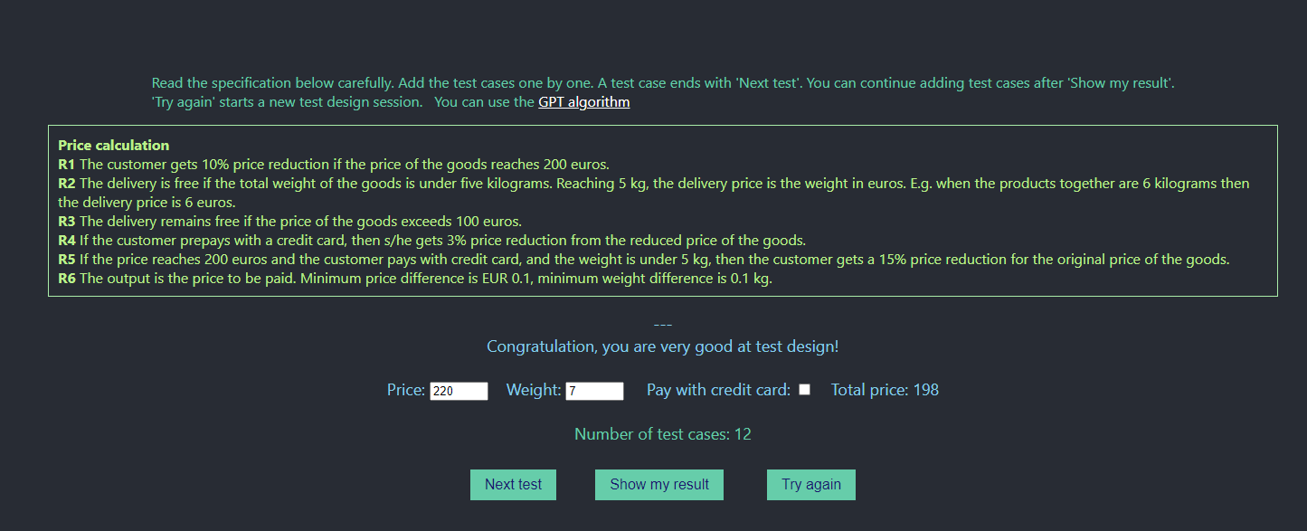

**Online book store**

**R1 For online new book purchasing regular customers with cards obtain 10% price reduction.**

**R2 Similarly, any customer buying new books for at least EUR 50 gets 10% price reduction.**

**R3 If somebody has a card and buys new books not less than EUR 50, then the price reduction is 15%.**

**R4 If a customer buys second hand books s/he gets price reduction 5%, but only if the price of them exceeds EUR 60 and s/he also buys new books for more than EUR 30.**

**R5 The output is the price to be paid. Minimum price difference: 0.01 euro.**

**TESTCASE:**

1. Test that the customer buy new books with cards, greater than EUR 50 that customer get 15% price reduction
2. Test that the customer buy new book with cards, less than EUR 50 that customer get 10% price reduction
3. To verify that the customer buy new books without cards, greater than EUR 50 price reduction is 10%
4. To verify that the customer buy new books without cards, less than EUR 50 price reduction is not applicable
5. To check that the customer buy second hand books, but if the price of them exceeds EUR 60 and also buy new books for more than EUR 30 with cards, price reduction is 5% for second hand books and 10% for new books
6. To check that the customer buy second hand books, but if the price of them exceeds EUR 60 and also buy new books for less than EUR 30 with cards, price reduction is 10% for new books and price reduction is not applicable for second hand books
7. To check that the customer buy second hand books, but if the price of them less than EUR 60 and also buy new books for more than EUR 30 with cards, price reduction is 10% for new books and price reduction is not applicable for second hand books
8. To check that the customer buy second hand books, but if the price of them less than EUR 60 and also buy new books for less than EUR 30 with cards price reduction is 10% for new books and price reduction is not applicable for second hand books
9. To check that the customer buy second hand books, but if the price of them exceeds EUR 60 and also buy new books for greater than EUR 50 with cards price reduction is 15% for new books and 5% for second hand books
10. To check that the customer buy second hand books, but if the price of them less than EUR 60 and also buy new books for greater than EUR 50 with cards price reduction is 15% for new books and price reduction is not applicable for second hand books
11. To check that the customer buy second hand books, but if the price of them exceeds EUR 60 and also buy new books for greater than EUR 30 without cards price reduction is 5% for second hand books and price reduction is not applicable for new books
12. To check that the customer buy second hand books, but if the price of them exceeds EUR 60 and also buy new books for less than EUR 30 without cards price reduction is not applicable for second hand books and also not applicable for new books
13. To check that the customer buy second hand books, but if the price of them less than EUR 60 and also buy new books for greater than EUR 30 without cards price reduction is not applicable for second hand books and also not applicable for new books
14. To check that the customer buy second hand books, but if the price of them less than EUR 60 and also buy new books for less than EUR 30 without cards price reduction is not applicable for second hand books and also not applicable for new books
15. To check that the customer buy second hand books, but if the price of them exceeds EUR 60 and also buy new books for greater than EUR 50 without cards price reduction is 5% for second hand books and also 10% for new books
16. To check that the customer buy second hand books, but if the price of them less than EUR 60 and also buy new books for greater than EUR 50 without cards price reduction is not applicable for second hand books and get 10% reduction for new books

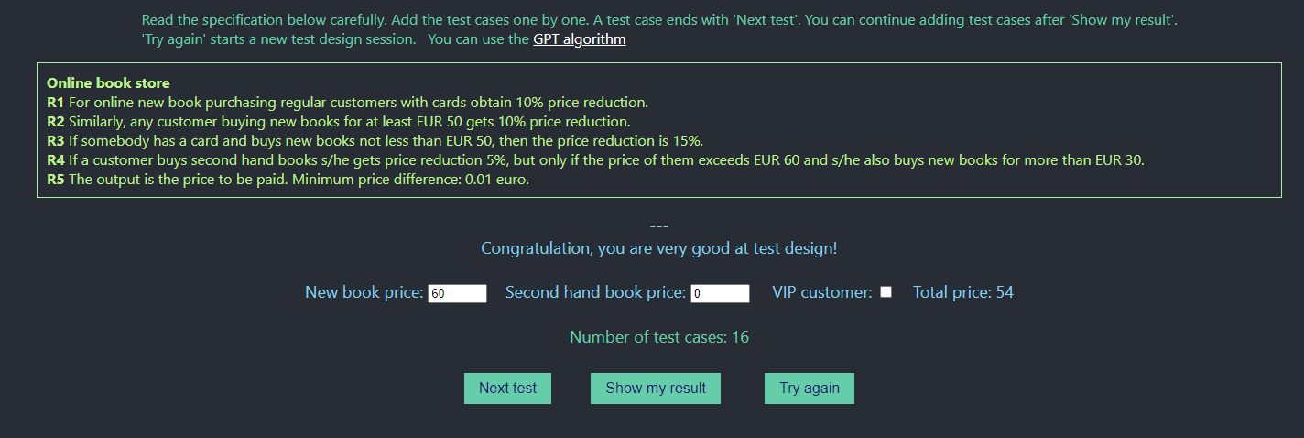

**Paid Vacation Days Calculation**

**R1 The number of vacation days depends on age and years of service. Every employee receives at least 22 days per year. Additional days are provided according to the following criteria:**

**R1-1 Employees younger than 18 or at least 60 years, or employees with at least 30 years of service will receive 5 extra days.**

**R1-2 Employees of age 60 or more with at least 30 years of service , receive 3 extra days, on top of possible additional days already given based on R1-1.**

**R1-3 If an employee has at least 15 years of service, 2 extra days are given. These two days are also provided for employees of age 45 or more. These extra days cannot be combined with the other extra days.**

**Display the vacation days. The ages are integers and calculated with respect to 31th December of the current year.**

**TESTCASE:**

1. To check if the employees of age greater than 18, or employees with less than 15 years of service, that employees will receive at least 22 days per year
2. To check if the employees of age greater than 18, oremployees with at least 15 years of service , that employees will receive additional 2 days
3. To check if the employees of age greater than 18, oremployees with at least 30 years of service , that employees will receive additional 5 days
4. To check if the employees of age greater than 45, that employees will receive additional 2 days
5. To check if the employees of age greater than 18 or less than 45 ,or employees with at least 15 years of service, that employees will receive additional 2 days
6. To check if the employees of age greater than 18 or less than 45 ,or employees with at least 30 years of service, that employees will receive additional 5 days
7. To verify that the employees of age more than 60, that employees will receive 5 additional days
8. To check if the employees of age more than 60 , that employees will receive additional 3 days ,oremployees with at least 30 years of service , that employees will receive additional 5 days, this extra days are added to already received additional days
9. To check if the employees of age more than 60 , that employees will receive additional 3 days ,oremployees with at least 15 years of service , that employees will receive additional 2 days, this extra days are added to already received additional days

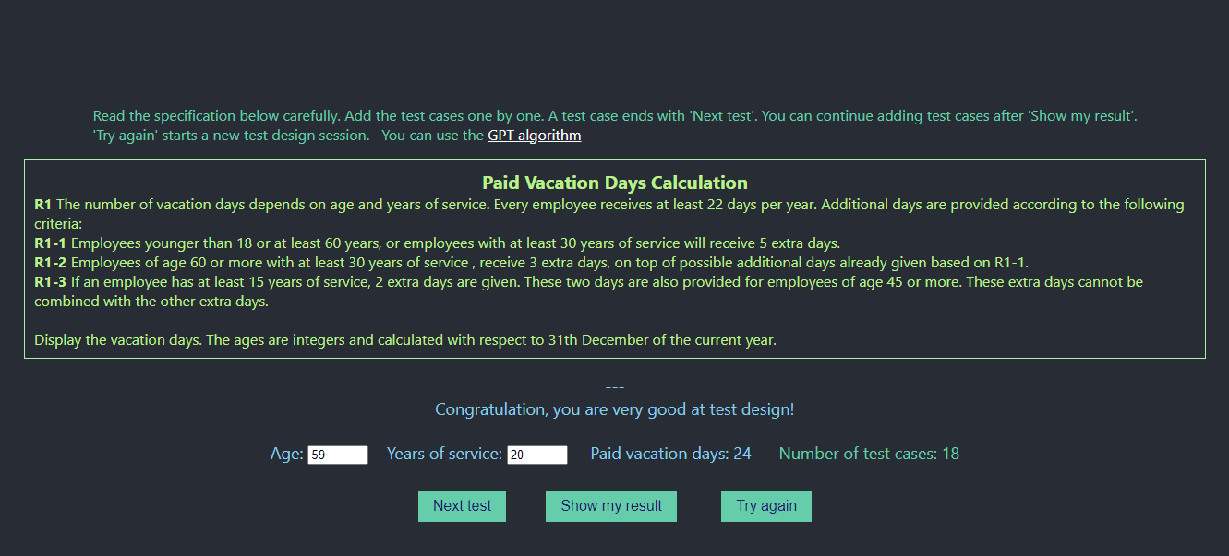

**University course grade system**

**R1 A university course grade system evaluates grades based on the following ingredients:**

**blackboard exercises (BE) in the range from 0 to 50 points,**

**laboratory exercises (LE) in the range from 0 to 50 points,**

**written part (WP), also in the range of 0 - 50 points,**

**R2 The sum of partial grades SUM = (BE + LE + WP) is calculated and the final grade follows the following rules:**

**R2-1 If any of BE, LE, WP is under 25 points - failed.**

**R2-2 SUM is less than 76 points – failed.**

**R2-3 SUM is 76 - 100 points - satisfactory.**

**R2-4 SUM is 101 - 125 points – good.**

**R2-5 SUM is greater than 125 points - very good.**

**The output is the result set, i.e., failed/satisfactory/good/very good.**

**TESTCASE:**

1. To check that the BE,LE and WP is less than 25, it is fail
2. To verify that the SUM is less than 76, it is failed
3. To verify if BE is less than 25, LE is greater than 25 and WP is greater than 25, the grade is failed
4. To verify if BE is greater than 25, LE is less than 25 and WP is greater than 25, the grade is failed
5. To verify if BE is greater than 25, LE is greater than 25 and WP is less than 25, the grade is failed
6. To verify if BE is less than 25, LE is less than 25 and WP is greater than 25, the grade is failed
7. To verify if BE is greater than 25, LE is less than 25 and WP is less than 25, the grade is failed
8. To verify if BE is less than 25, LE is greater than 25 and WP is less than 25, the grade is failed
9. To verify if BE is less than 25, LE is less than 25 and WP is less than 25, the grade is failed
10. To verify if BE is greater than 25, LE is greater than 25 and WP is greater than 25, it is pass
11. To verify that the SUM is greater than 76 or less than 100, the grade is satisfactory
12. To verify that the SUM is greater than 101 or less than 125, the grade is good
13. To verify that the SUM is greater than 125, the grade is very good

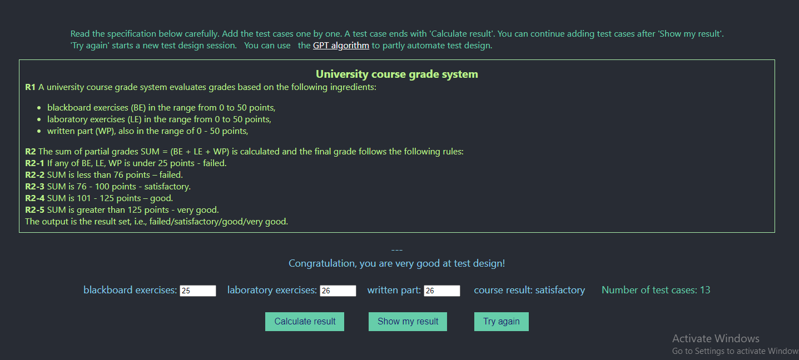

**Car Rental**

**A rental company loans cars (EUR 300), motorcycles (EUR 150), and bikes (EUR 100) for a week. Pre-booking can be done on the company's website as follows.**

**R1 The customer can add one car, motorcycle, or bike at a time to the rental order.**

**R2 The customer can remove one car, motorcycle, or bike at a time from the rental order.**

**R3 If the customer rents two cars or one car and two motorcycles, then they can rent one bike for free. In case of discount:**

**R3a If the customer has selected some bikes previously, then one of them becomes free.**

**R3b If the customer hasn't selected a bike previously, then one free bike is added.**

**R3c If the customer deletes the free bike from the order, then the total price will be reduced by EUR 50. Adding a bike back, it becomes free.**

**R3d When an offering is withdrawn but given again, and no bike was added/deleted meanwhile, the customer gets the previous offering back.**

**R3e When the offering is withdrawn and some bikes are added, when the offering is given again then one of them becomes free.**

**R4 If the customer deletes some cars or motorcycles from the order that the offering threshold doesn't hold, then any offering will be withdrawn.**

**R5 Display the total rental price after each activity.**

1. Toverify that the rental cars loan is EUR 300,rental motorcycle loan is EUR 150 and rental bike loan is EUR 100
2. To verify that the customer can add one car, one motorcycle and one bike at a time
3. To verify that the customer can remove one car, one motorcycle and one bike at a time
4. To verify that the customer rents two cars, the customer can rent one bike for free
5. To verify that the customer rents one car and two motorcycles, the customer can rent one bike for free
6. To verify that the customer delete that free bike, the customer will reduced by EUR 50
7. To verify that the customer delete that free bike, the customer will reduced by EUR 50 after adding the bike the reduction is not applicable
8. To verify that the customer delete that free bike, then add one bike, the customer can rent one bike for free

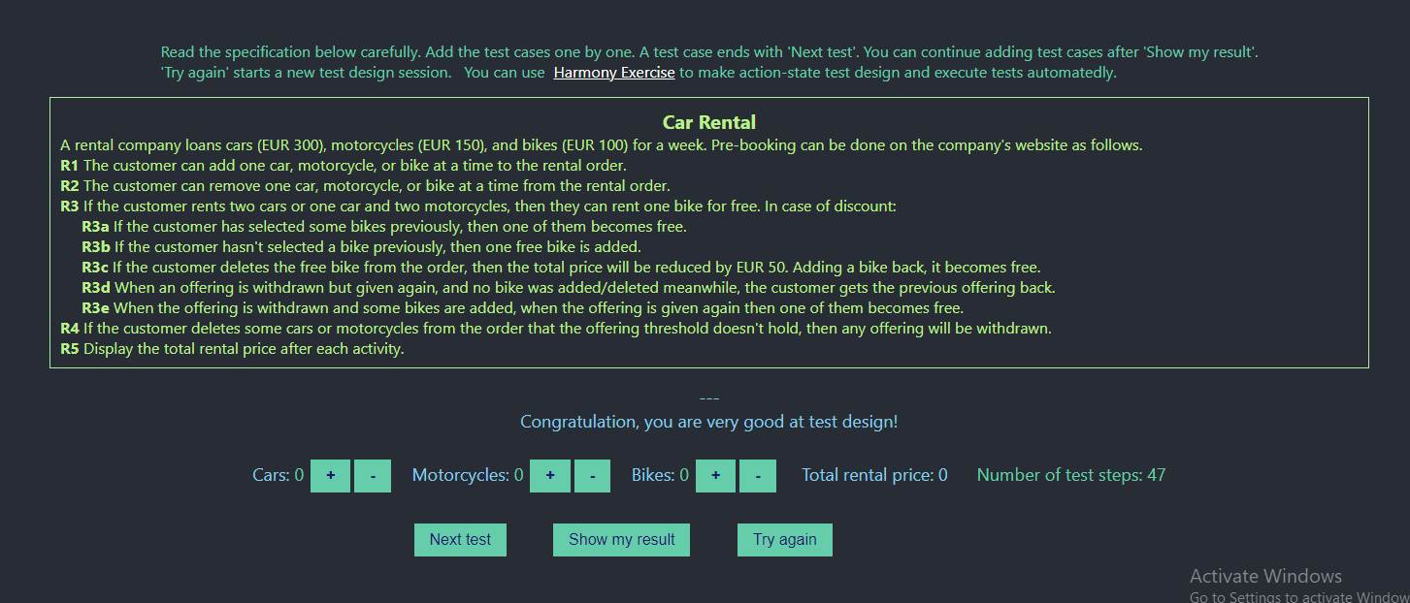

**Tour competition**

**A tour competition application can handle registered teams as follows:**

**R1 During the registration process a unique team name together with globally unique team members can be entered. A team has at least one and at most three members. The registration is activated when ‘Add team’ is pressed.**

**R2 After entering an existing team name, missing team members can be added and existing team members can be deleted or modified.**

**R3 Members of incomplete teams can be ‘stolen’, i.e., they can be added to another team during registration or modification, only if the 'thief' team is complete.**

**R4 It is not allowed to construct a team only from 'stolen' members.**

**R5 If all the team members have been 'stolen' from a team, it’s deleted automatically, and no new team can be registered with the deleted team’s name.**

**R6 Stolen member cannot be modified only deleted. Stolen members can be further stolen from incomplete teams.**

**For simplicity, authentication is ignored. Thus, if you enter an existing team name, it's a team modification. No test to validate team uniqueness is possible.**

1. To verify that the teams have unique name or not
2. To verify that the team has at least one member and at most three members
3. To verify if entering the team details are inserted or not
4. To verify if entering only the team name and team members cannot be entered, that team details should be insert or not
5. To verify if entering an existing team name, missing team members can be added, existing team members can be deleted or modified
6. To verify if that team members having same name, that team details are insert or not
7. To verify that the team have two members then we can add one new member, team can modified or not
8. To verify that the deleted team’s name can be registered as a new team name
9. To verify that the team members are incomplete n a team, that team can be stolen
10. To verify if any team is stolen, that team is not allowed
11. To verify if any team members have been stolen from a team, it’s delete automatically
12. To verify that the stolen members can be modified or not
13. To verify that the stolen members are can be deleted or not

**Online pizza ordering**

**R0 In a Pizza Ordering service foods/beverages are offered (the prices are in euro): Pizza fresca - 18, Pizza pollo - 15, Coke - 3, Beer - 4**

**R1 Before any user action is initiated the ordered number of items is 0.**

**R2 The user can increase the ordered number of items by pressing "+" next to the item.**

**R3 The user can delete (set to 0) the ordered number of items by pressing “X“ next to the item.**

**R4 If the total price excluding beverages reaches 45 euros for the first time, a present beverage is offered to the customer. The user can select one free Coke or Beer which is added to the previously ordered beverages. ‘Free coke’ or ‘Free beer’ is displayed when a free beverage is on the ordered list.**

**R5 The free beverage cannot be changed from coke to beer or vice versa.**

**R6 If the customer deletes food items and goes below 45 euros, then the free beverage has been withdrawn until this price remains under 45 euros.**

**R7 The customer can delete the free beverage. When the non-beverage price condition holds and she adds the same beverage again, it remains free.**

**R8 The customer can clear all the items. Adding enough foods again she can select any free beverage.**

**TEST CASE:**

1. To verify that the price of Pizza fresca is 18 euros, price of Pizza pollo –is 15 euros, price of Coke is 3 euros, price of Beer is 4 euros
2. To verify that the number of items is 0, before any user start with ordered
3. To check that the user can press “+”,the user can increase the ordered number of items
4. To check that the user can press “x”, the user can decrease the ordered number of items
5. To verify that the user can add pizza fresca, pizza pollo, coke and beer at a time
6. To verify that the user can delete pizza fresca, pizza pollo, coke and beer at a time
7. To verify if the total price to reaches 45 euros at first time, that user can get one free coke or one free beer
8. To verify if the total price less than 45 euros, that user cannot get free coke or free beer
9. To verify if the total price to reaches 45 euros at first time, that user can get one free coke or one free beer, then the user can delete the items and the price is under 45 euros, the free beer or coke is not applicable

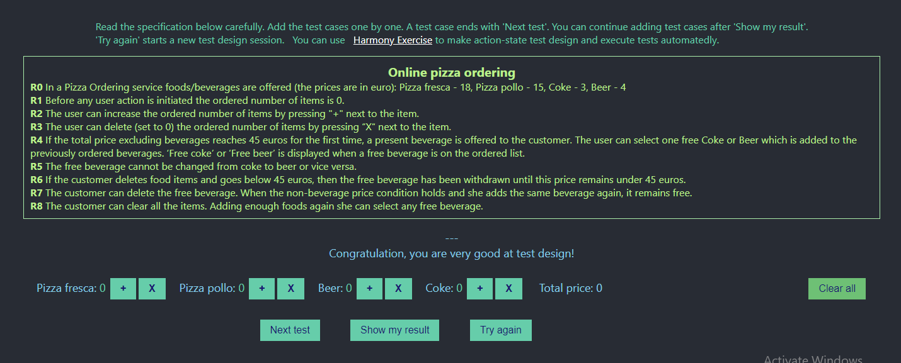

**Extra holiday**

**These requirements are the figment of imagination and not related to any real workplace 😊**

**R1 An employee can do overtime (overtime++).**

**R2 Doing overtime three times results in a free day (overtime = 0, free day++).**

**R3 An employee can take a free day by pressing – (free day--).**

**R4 If an employee is late, then one overtime is withdrawn (overtime--, if overtime = 0 → free day--, overtime = 2).**

**R5 If an employee takes three free days without lateness, then for the subsequent one-time lateness her accepted overtime remains unchanged.**

**R6 If an employee is late and overtime ≤ 0 and free days ≤ 0 then two overtimes are withdrawn (overtime = -2, free day = 0 → overtime = -1, free day = -1).**

**R7 If the number of free days is reduced to minus three, then GAME OVER!**

**Test that the code satisfies the requirements.**

**TEST CASE:**

1. To verify that the employee can do overtime, that overtime will be added or not
2. To verify that the overtime can added three time, that employee get one free day
3. To verify if overtime can added three times then add a lateness, that employee will lose one overtime
4. To verify if an employee is late, then one overtime is withdrawn and free day also decrease
5. To verify if employee is late and don’t have an overtime, then overtime is withdrawn
6. To verify if an employee have -2 overtime, then add one -1 overtime, that employee have -1 free day

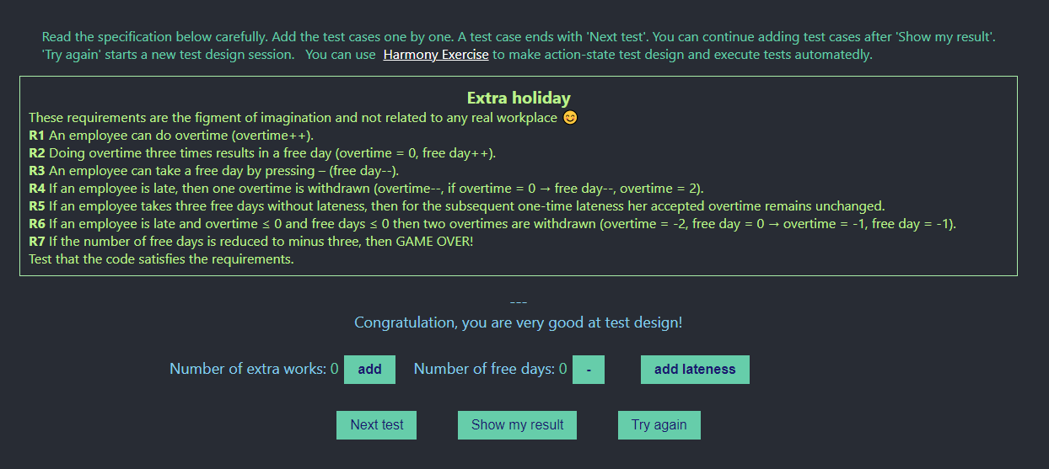

**Online grocery**

**In an online grocery, you have the following price reduction.**

**R1 If you buy for at least EUR 1000 within a calendar year then a 5% price reduction can be claimed for the subsequent purchases in that calendar year.**

**R2 When you claim a price reduction, the amount you currently spend is not involved in the calendar year (total) spending.**

**R3 If you don’t ask for price reduction then the double amount of the current purchase is added to your total spending.**

**R4 If your total spending with corrections reaches EUR 2000, then an 8% reduction can be claimed and if you ask for this price reduction, the current amount is added to your calendar year spending.**

**R5 If your total spending with corrections reaches EUR 3000, then in the subsequent calendar year your initial spending is 25% of your previous year total spending (instead of zero).**

**R6 The total spending with corrections is displayed when you enter the grocery and is not changing during your purchase.**

**R7 The price to be paid for your purchase is displayed.**

**A purchase happens after clicking on 'I buy it'. The input price accuracy is 1.**

**TEST CASE:**

1. To verify that the customer buy for at least EUR 1000, then that customer get 5% of price reduction
2. To verify that the customer buy for less than EUR 1000, the price reduction is not applicable
3. To verify that the customer buy for at least EUR 2000, then that customer get 8% of price reduction
4. To verify that the customer buy for at least EUR 3000, then that customer get 8% of price reduction
5. To verify that the customer buy for at least EUR 3000 and buy for next year, then that customer get 8% of price reduction and pay for 25% of initial amount for this year
6. To verify that the customer buy for less than EUR 2000, then that customer get 5% of price reduction and 25% of initial spending is not applicable
7. To verify that the customer buy for less than EUR 3000, then that customer get 8% of price reduction and 25% of initial spending is not applicable

